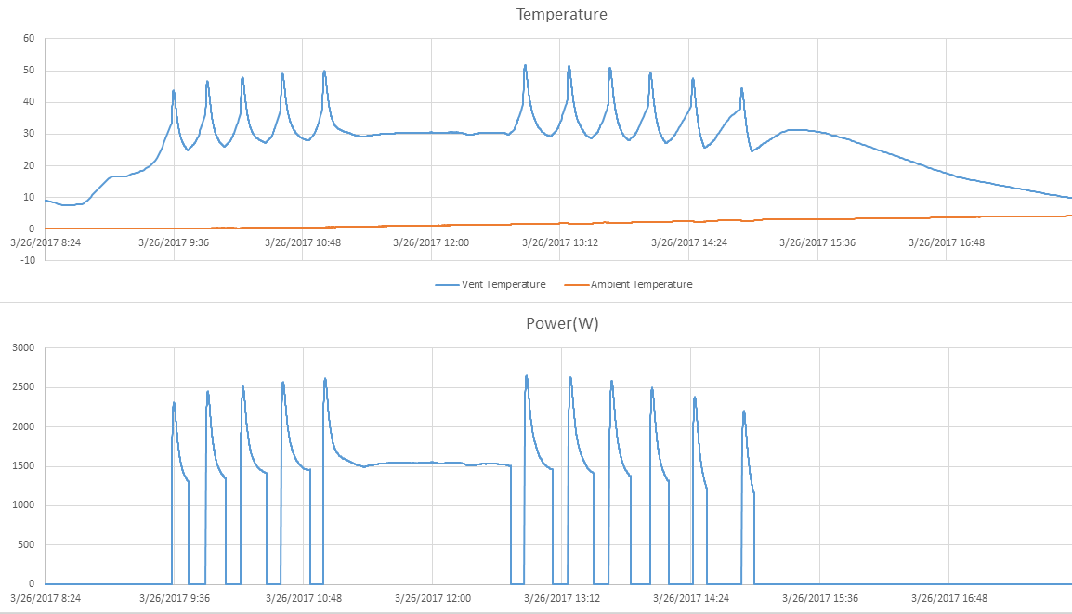

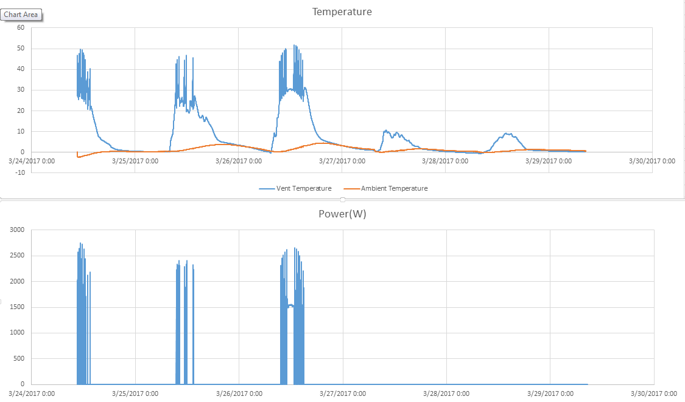

|  |  |
| --- | --- |
| Date | Energy Generated in kWh |
| 2017-03-24 | 1.411610553 |
| 2017-03-25 | 0.755249745 |
| 2017-03-26 | 3.561938809 |
| 2017-03-27 | 0 |
| 2017-03-28 | 0 |
|  |  |

